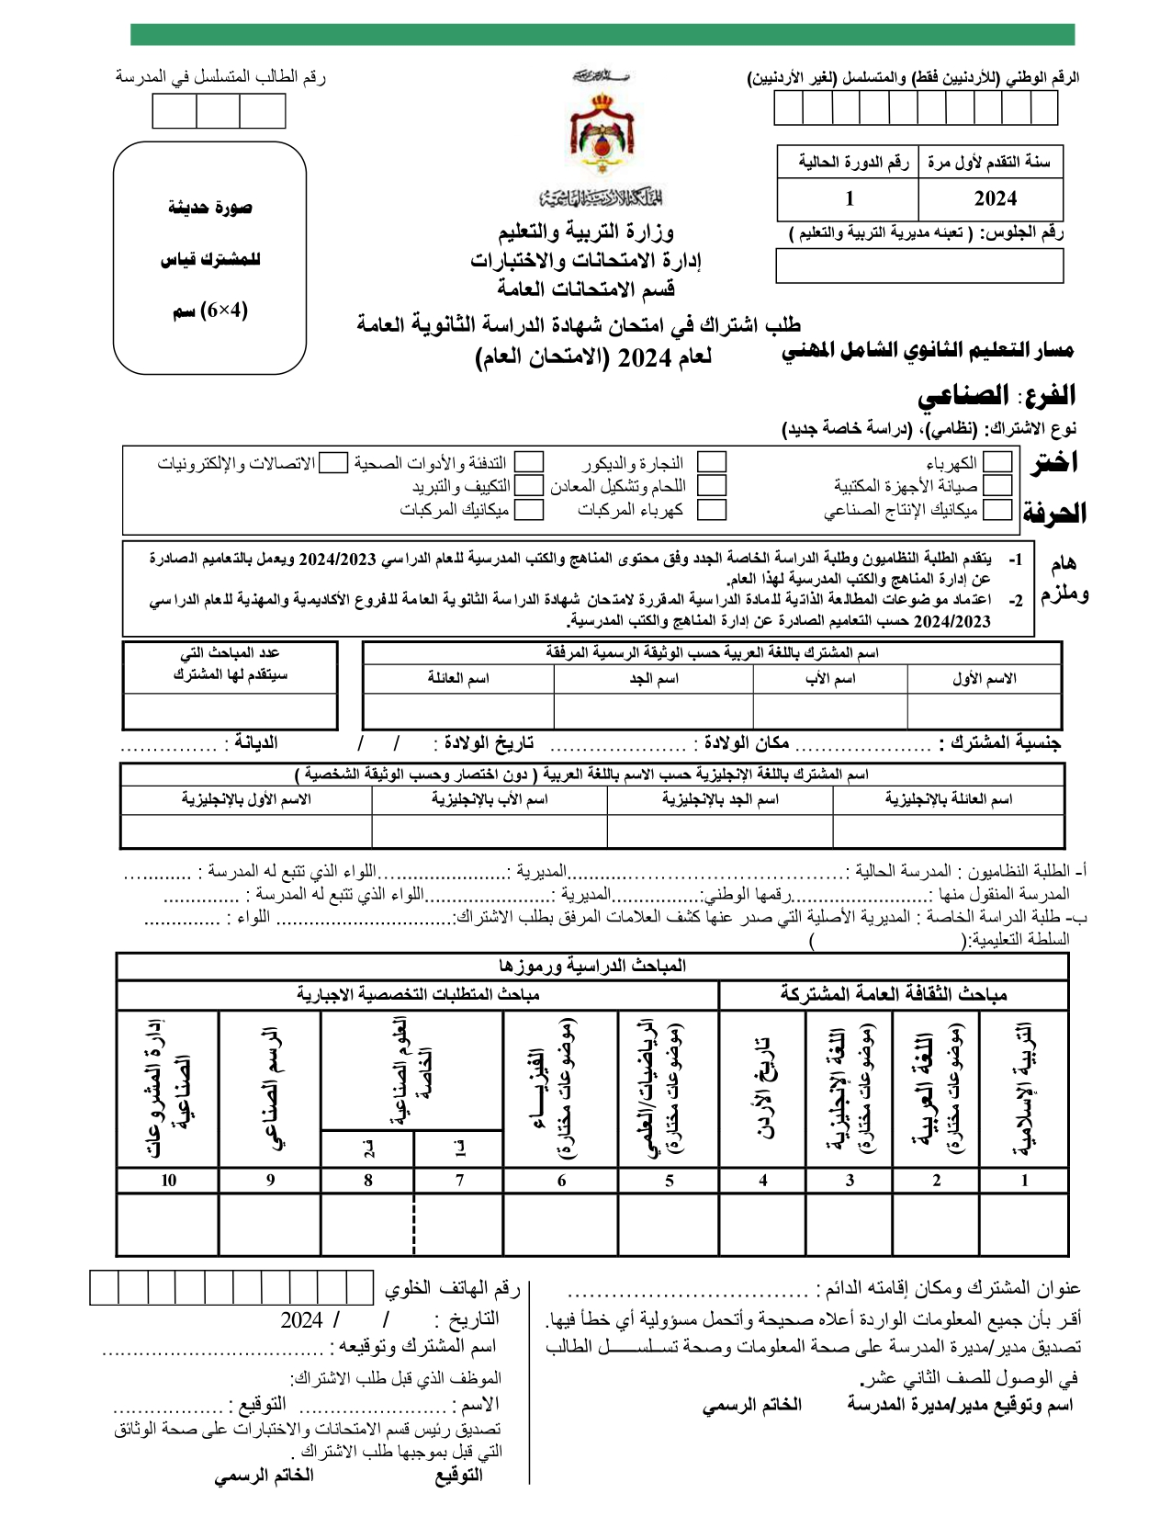

|  |  |  |  |  |  |  |  |  |  |  |
| --- | --- | --- | --- | --- | --- | --- | --- | --- | --- | --- |
|  | **«n1»** | **«n2»** | **«n3»** | **«n4»** | **«n5»** | **«n6»** | **«n7»** | **«n8»** | **«n9»** | **«n10»** |

|  |  |  |  |  |
| --- | --- | --- | --- | --- |
|  | **«stn1»** | **«stn2»** | **«stn3»** | **«stn4»** |

|  |  |  |  |  |  |  |
| --- | --- | --- | --- | --- | --- | --- |
|  |  | **+school+** |  | **+mod+** |  | **+lewa+** |

|  |  |  |  |  |  |  |  |  |  |
| --- | --- | --- | --- | --- | --- | --- | --- | --- | --- |
|  | **«nat»** |  | **«pp»** |  | **«pd1»** | **«pd2»** | **«pd3»** |  | **«deyaneh»** |

|  |
| --- |
| **+modeer+** |